**Notes on changes from v1 to v2:**

* Moving most text instructions to “More instructions” at end
* Breaking apart diagrams because the larger ones look too small given the limitations of the instruction viewer
  + Trying to include some other example images in first section of instructions and still have some in “more instructions” page but not sure how I should best break this out.
  + Definitely want a good vs bad example of acetabulum thing at the beginning
* Removing thing about “we may reject seg if <15 points” at beginning, replacing with note at end that mentions that submissions are graded, changing thing about rejection to idea that if they do well they may be invited to do more segs(!)
* Adding a thing at the start simply mentioning that looking at the “more instructions” page may be very useful

**BEGIN INSTRUCTIONS**

**Note: It is much easier to complete this task if you first look through the example segmentations below. The “More instructions” section contains additional written instructions and examples of good and bad segmentations.**

This is a semantic segmentation task used for medical analysis. Your task is to outline the area that contains the femur bone in each image.

A cartoon of a pelvis is shown below. The circled region is approximately the area shown in the real images.

**Examples**

**Example 1**

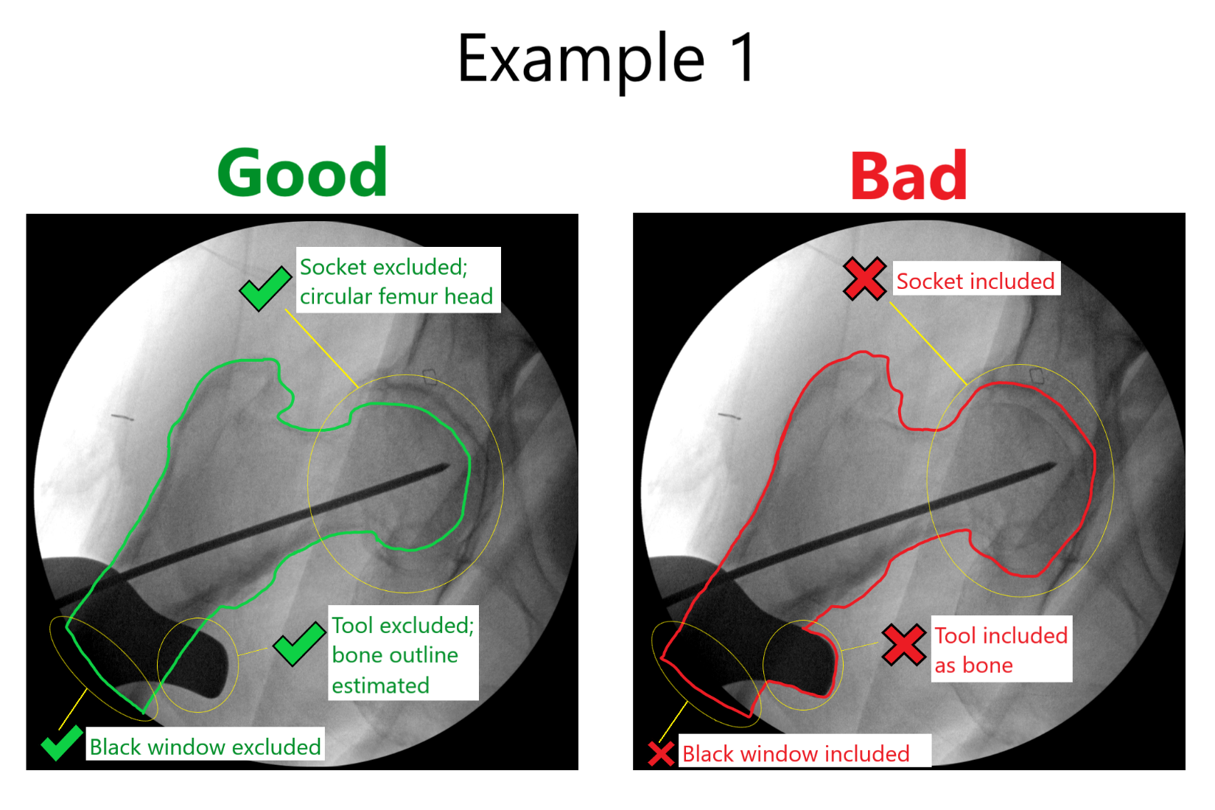

**Example 2**

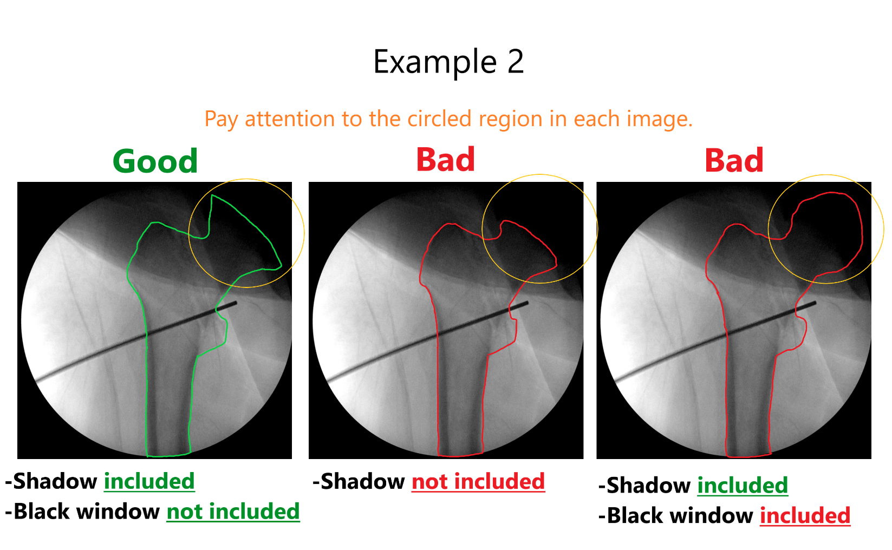

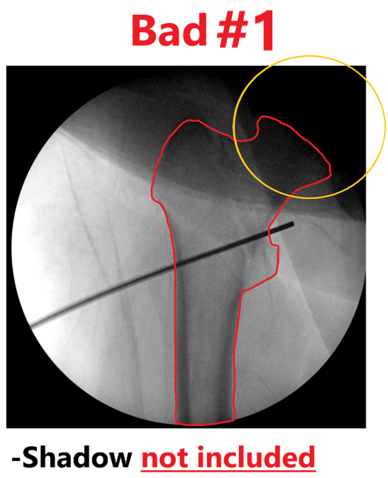

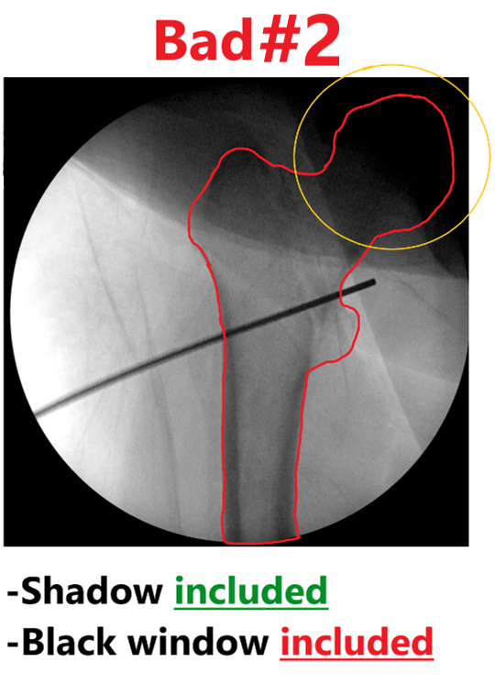

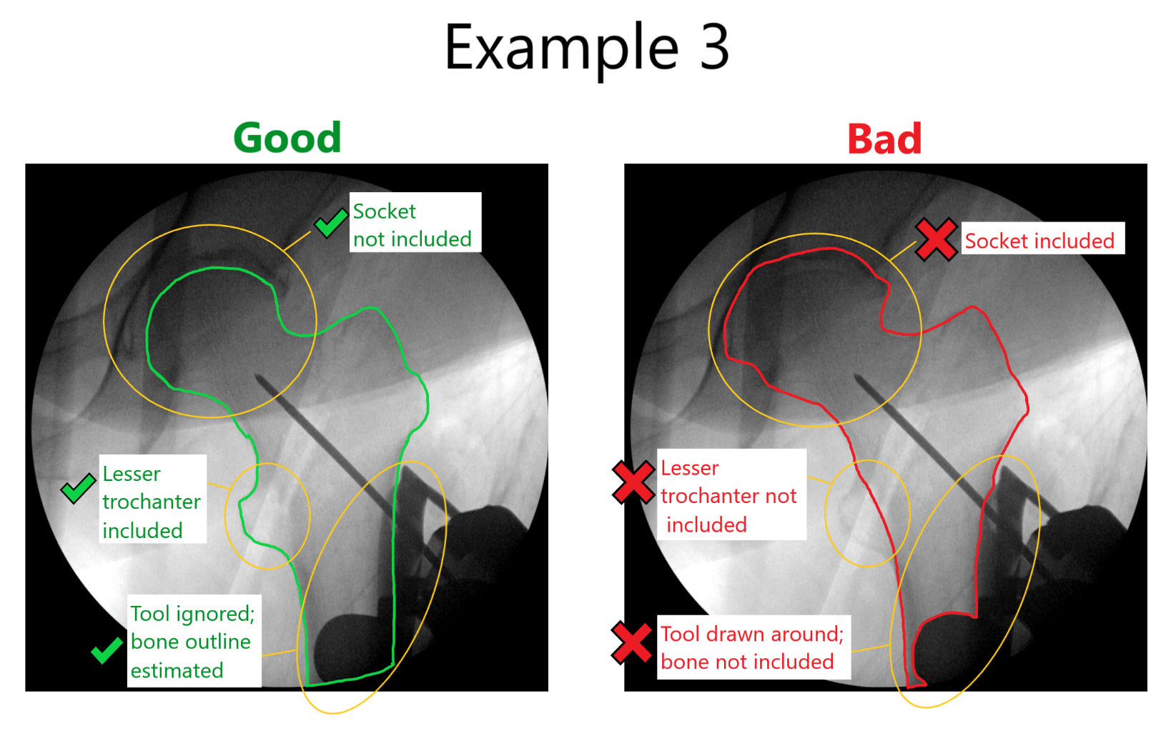

**MORE INSTRUCTIONS**

This is a semantic segmentation task used for medical analysis. The dataset contains images similar to x-rays in which the femur (thighbone) is at least partially visible in a circular view with a black background (referred to as “black window” in examples). Your task is to outline the area that contains the femur bone in each image.

* Be especially careful to correctly outline the femur head (“ball”). A common mistake is to include the “socket” surrounding the femur head where the femur connects to the rest of the pelvis. (See examples)
* Ignore any obstructions from tools, surgical wires, and shadows when determining the outline of the bone. Sometimes, it is necessary to estimate where the bone is behind a large obstruction.
* Never include parts of the black background outside of the circular view, even when estimating near an obstruction.
* All images in the dataset show the femur from a front (“anterior”) or back (“posterior”) view. The diagram above shows an anterior view. Below is a diagram showing a more detailed anatomy of the femur in anterior and posterior views.

**Note: Segmentation submissions are graded. Good performers may be invited back to do more images.**